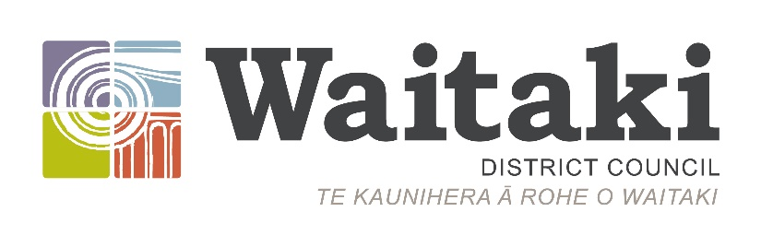
Citizens’ Awards

Confidential

Nomination Form 2023

The Waitaki District Citizens’ Awards are given in recognition of substantial service, usually of a voluntary nature or beyond normal employment, benefiting the Waitaki District and its people.

Closing Date for Nominations

Monday 31 july 2023 at 5.00pm

Please print
Name of Nominee
Title

First Name _

Surname

Address

Email ____________________________________________________

Phone (daytime) (evening) ____

Mobile Phone number: __________________

Date of Birth (if known – or approx. age) __________________

The nomination fits in the following category:

Recreational | Youth activities | Social Welfare | Educational Services | Cultural Affairs | Religious Affairs | Community Affairs | Other Voluntary Service

Please list below examples of:

- Community activities / projects the nominee has been involved in both past and present
- Positions of responsibility held by the nominee within organisations/community groups etc.
- Any community involvement, years of service the nominee has

Service Organisations, Clubs,  etc. | Position/s Held | Years of Service in Each Position

Please describe / show how you believe the nominee has made a significant contribution to the well-being of the Waitaki District and its citizens.

Other Awards Received  Please list | Date Received (if known) | Reason for the Award

Nominated by:
Name:
Address:
Phone / Mobile | Email:
Signature: | Date:

Nomination seconded by:
Name:
Address:
Phone / Mobile | Email:
Signature: | Date:

Additional information:
If you have any additional information to support the nomination, please feel free to include this at the back of the nomination form. If you believe another person can add more information on another area the nominee has been involved in, please provide their name, and contact details to enable us to reach them.
Condition of nomination:
The decisions of the Selection Panel are final, and no correspondence will be entered into, or reasons given for any unsuccessful nomination. If the nomination is unsuccessful, it may be carried over to be considered again the following year.
Please return nomination form via post or email marked Confidential to:
Leanne Kingan
Waitaki District Council
Private Bag 50058
Oamaru 9444
Email: lkingan@waitaki.govt.nz
Phone: 433 0300

